SACRAMENTO YOUTH ALLIANCE

WHO WE ARE
Initiative of Alliance for Education Solutions
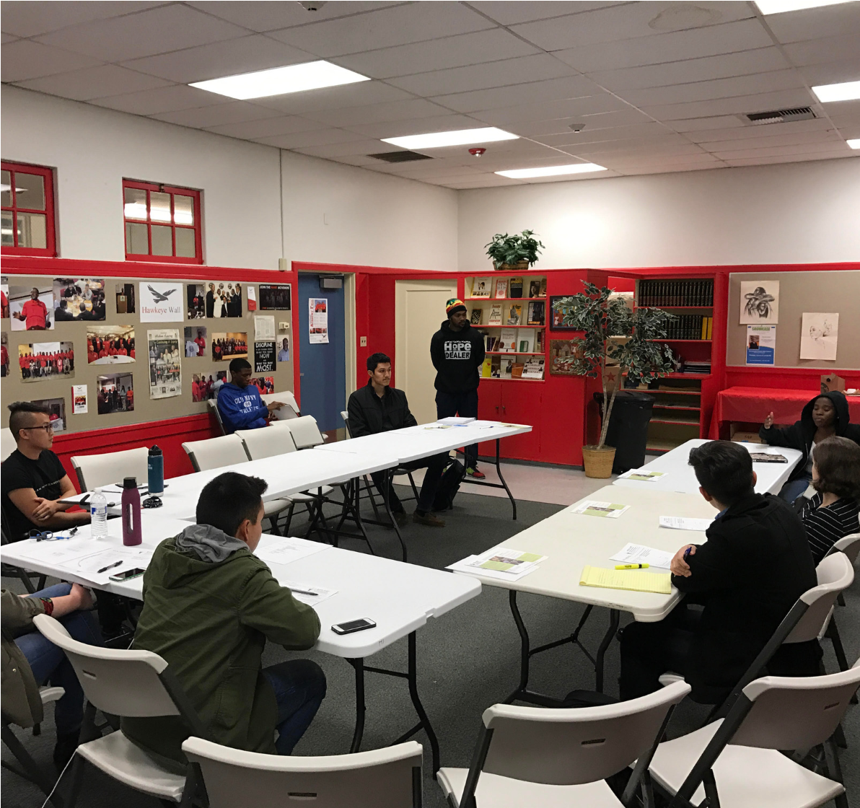
SYA is a group of youth advocates: ages 16-24 Advocates seeking services, resources and opportunities for Sacramento's youth; ages 16-24.

WHAT WE DO

ENGAGE
Reach out to youth to assure that they're engaged actively in decision making where they're stakeholders.
EDUCATE
Provide the tools and resources to leaders to create change in communities across Sacramento.
EMPOWER
Assure that these leaders feel empowered and motivated to create positive change.
Proposed Projects
- Support and advocate on behalf of the Sacramento Children’s Fund and current city youth initiatives
- Establishing a city-wide youth bill of rights
- Advocacy for higher quality school lunches and learning materials at local middle and high schools
- Promoting local civic engagement opportunities for Opportunity Youth
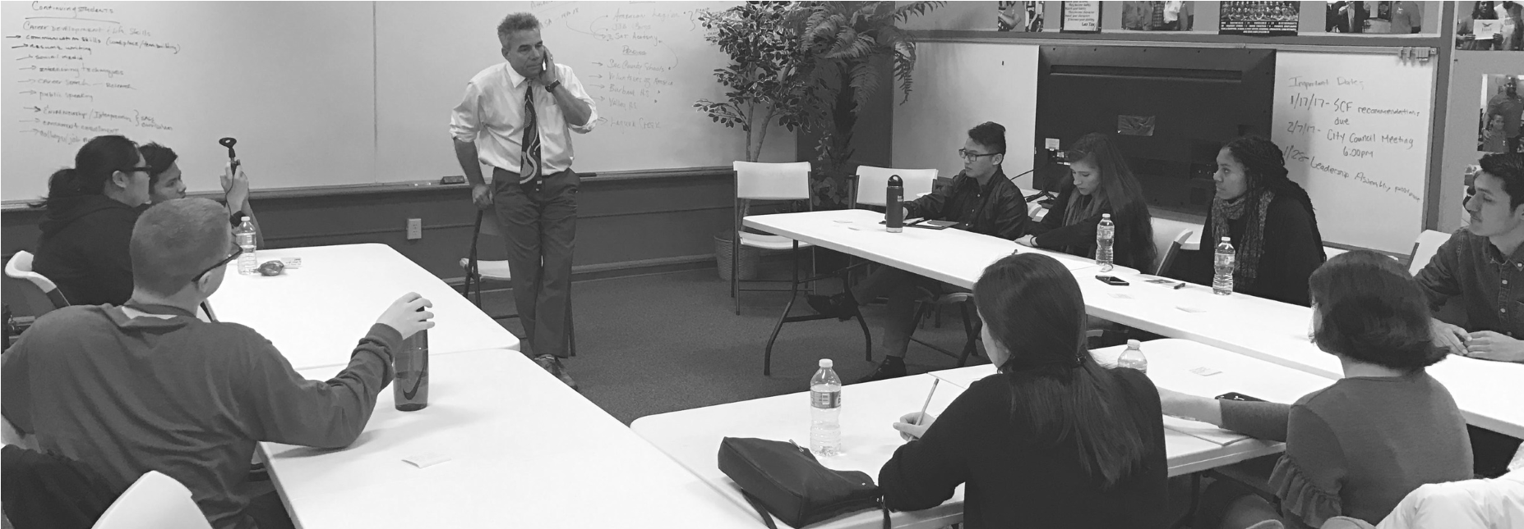

TRAININGS/RESEARCH

- We offer comprehensive information about youth-related issues in Sacramento
- Leadership and community development
- Civic engagement presentations aimed to engage Opportunity Youth
- We designate individuals to serve as legislative aides researching various issues affecting youth
- We compile recommendations on local city issues (ex: the Sacramento Children’s Fund)

WHY WE
NEED TO ACT
NOW

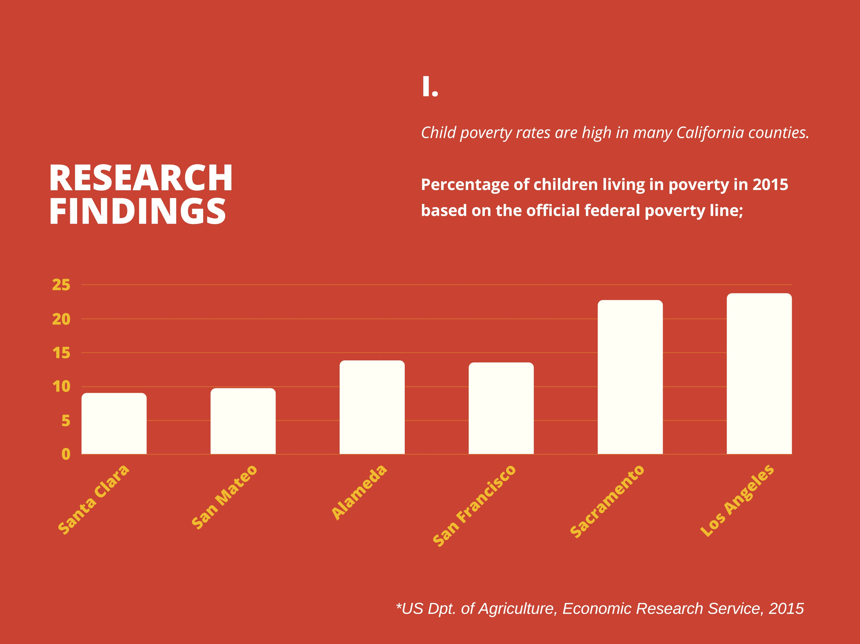
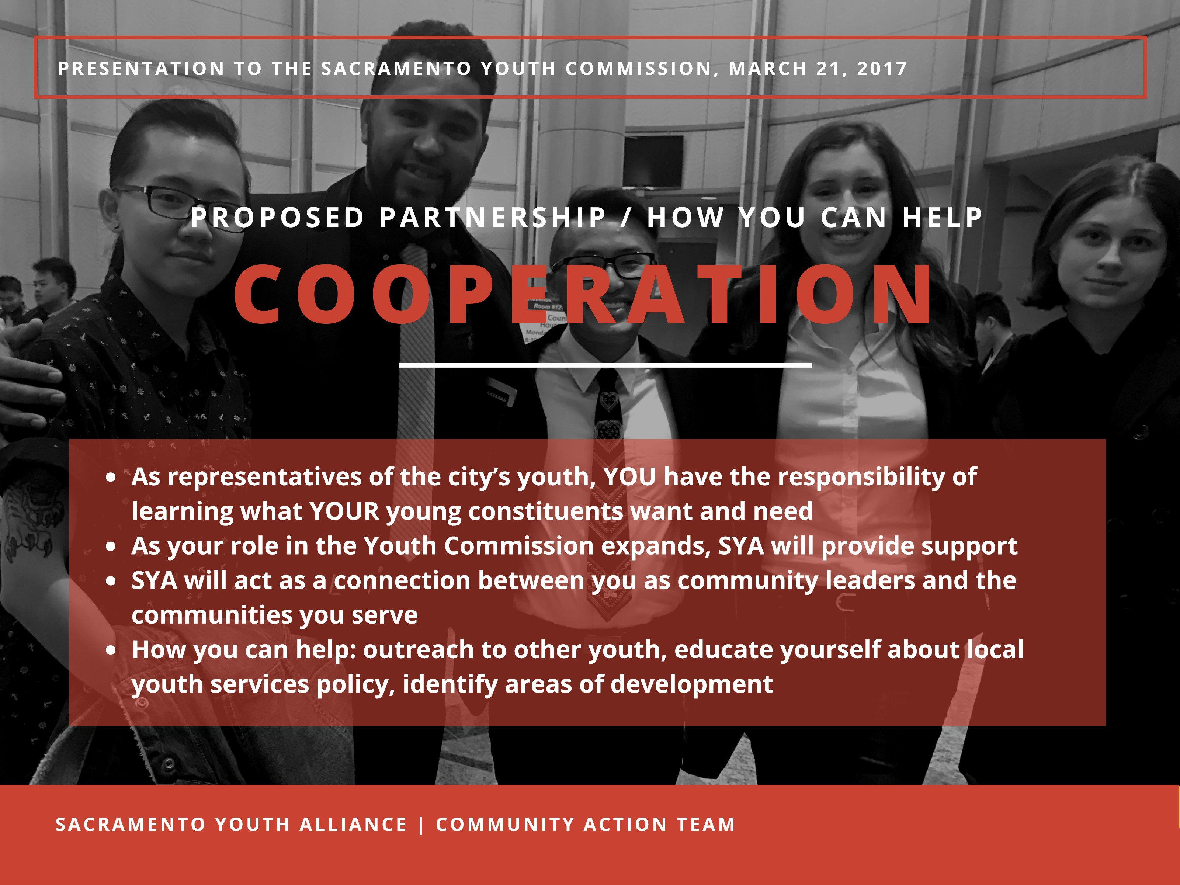
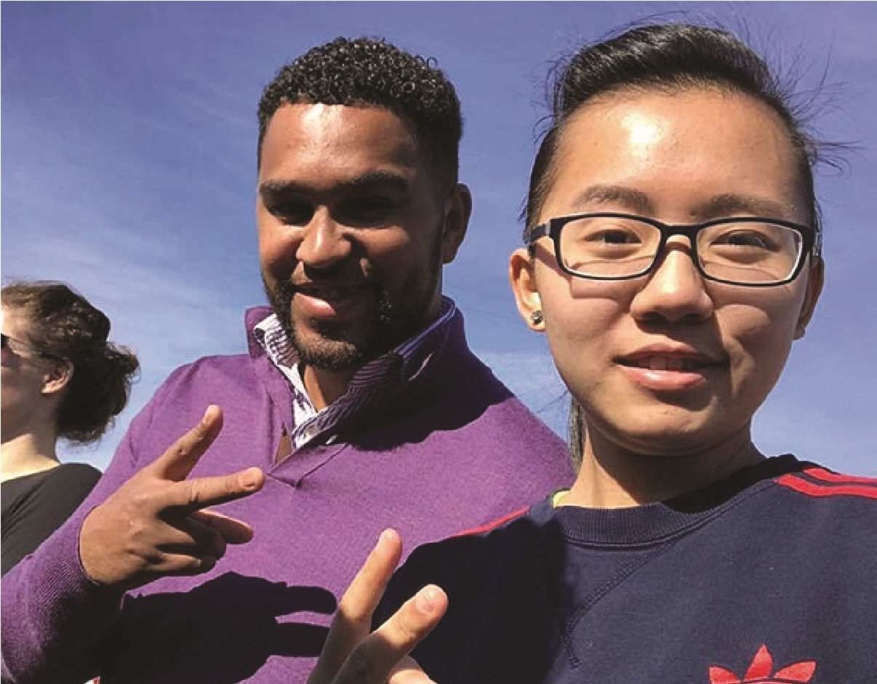
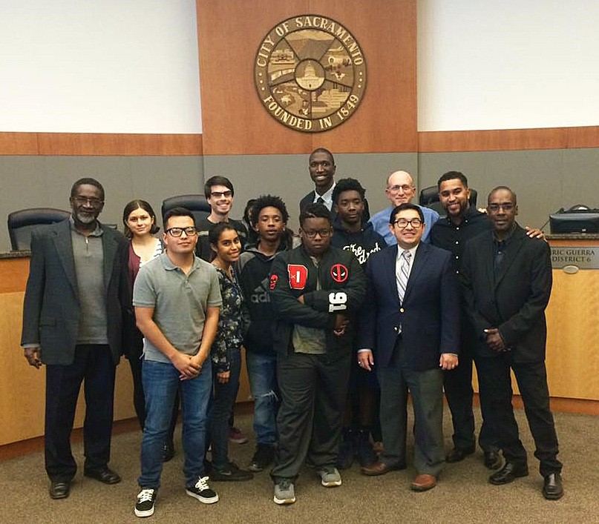
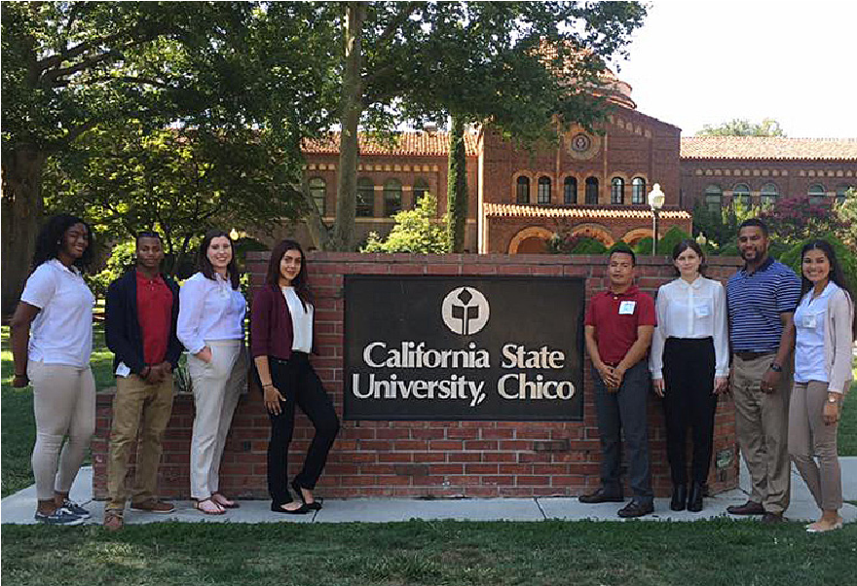
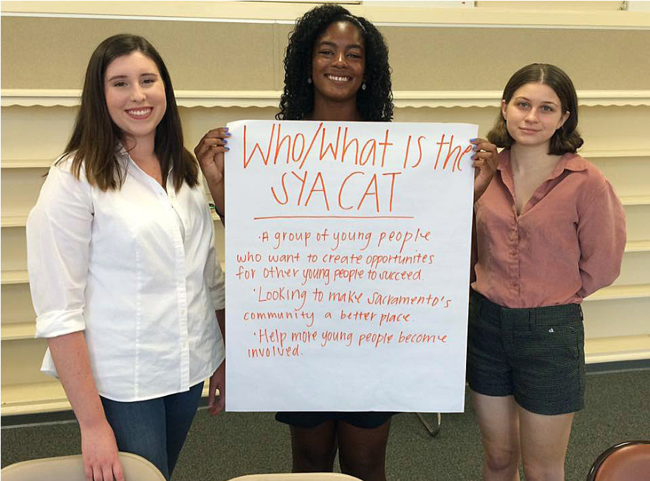
S
A
c
R
A
M
E
N
T
O

Y
O
U
T
H

A
L
L
I
A
N
C
E

|

C
O
M
M
U
N
I
T
Y

A
C
T
I
O
N

T
EAM

- Be the Voice of Change in your School or Community

- Be Part of a Youth Led Network
- Be a Leader and a Change Maker
Join the Movement
Sacramento Youth Alliance Community Action Team
An initiative of the Alliance for Education Solutions
W: www.aesimpact.org P:916-905-5814
E: SacramentoYouthAllianceCAT@gmail.com

